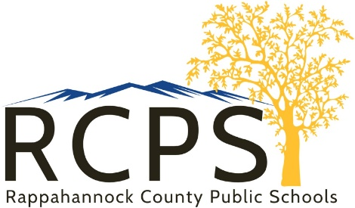

School Board Office
6 Schoolhouse Road
Washington, Virginia 22747
Telephone (540) 227-0023
Fax (540) 987-8896
www.rappahannockschools.us

ONLINE PAYMENT CENTER FOR SCHOOL MEALS

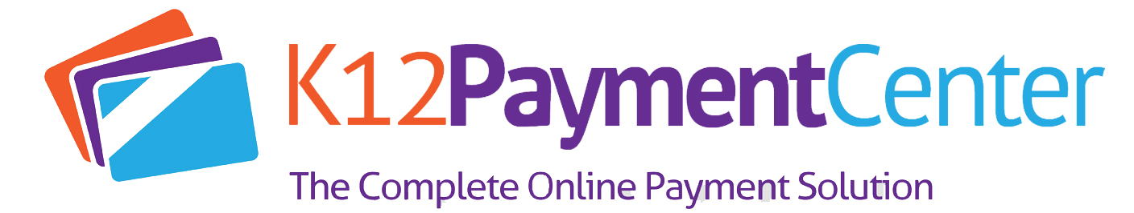

Dear Parent/Guardian,
Rappahannock County Public Schools has a new online payment center for school meals. Any balance your child had from last school year using MySchoolBucks has rolled over. The 2020 – 2021 school year, RCPS will utilize K12 Payment Center as an easy, secure website to add money to your child’s lunch account and track their purchases.
Please visit www.K12PaymentCenter.com and click “Register Now” to create an account. Select Rappahannock County Public Schools from the drop-down lists of school districts, fill in your information, input your credit or debit card information and you’re ready to go! Note that you will need your child’s student ID number. Please contact your child’s school for their ID number.

A few advantages to this new system is that if you have more than one child in the district, you can deposit money into multiple accounts with just one payment. There is a $1.95 credit card transaction fee or $0.95 e-check transaction fee. We will also continue to accept cash or check at the point of sale as well. As the parent, you will continue to be able to check your child’s meal balance, get low meal balance alerts by email or text, have the option to set-up reoccurring payments, and have easy access to see what your child is purchasing.

As a reminder, our free and reduced application is available for all families to fill out. Please see the paper form in your child’s back to school information or fill out online at www.lunchapplication.com.

If you have any questions, please call Amanda Butler at 540-227-0023.

